**Ch 10 - The Logic of Quantifiers**

* At this point we have introduced all the symbols of FOL
* **first-order** quantifiers allow us to make quantity claims about ordinary objects: blocks, people, numbers, sets, and so forth
  + both universal and existential quantifiers quantify over objects or things in the domain that we’re working with
* if in addition we want to make quantity claims about properties of the objects in our domain of discourse - for example we claim that Max and Claire share exactly two properties - then we need **second-order quantifiers**
* our language only has first-order quantifiers, so it is known as the language of first-order logic
* we now turn our attention to
  + logical consequence
  + logical truth
* the questions we have are
  + **what quantified sentences are logical truths**
  + **what arguments involving quantification are valid**
  + **what are the valid inference patterns involving quantifiers**
  + **how can we formalize these valid patterns of inference**

**tautologies and quantification**

* recall
  + we introduced quantifier symbols to the language of FOL
  + first we introduced the notion of a wff, which contains free variables
  + quantifiers attach to the wffs, binding their variables, and thus forming sentences
  + sentences are wffs where the variables are bound by quantifiers
* **do the notions of tautology, tautological consequence, and tautological equivalence apply to our new sentences, and if so, how?**
  + yes these notions do apply to quantified sentences, but there are additional details to take into account

**Consider the argument**

*∀x (Cube(x) → Small(x))*

*∀x Cube(x)*

*∀x Small(x)*

*For every object x, if x is a cube then it is small.*

*Every object x is a cube.*

*Therefore, every object x is small.*

This is a valid argument: whenever the two premises are true, the conclusion must be true.

But is this argument tautologically valid? Ie, is it valid due solely to the meanings of the structure of the sentences in terms of their truth-functional connectives?

This argument apparently uses modus ponens in the presence of quantified sentences. Is that really what is happening?

No, because if we change the quantifier to **∃**, the argument becomes invalid.

Thus, the validity does not depend solely on the truth-functional connectives. We cannot build a truth table for the argument in a general way that involves just atomic sentences and obtain a tautologically valid argument.

The argument has form

A

B

C

Which is not tautologically valid.

Remember that we are interested in logical consequence, and we previously used tautological consequence as an approximation to that notion. As we see above, there are arguments containing quantified sentences that are valid (ie a conclusion is a logical consequence of the premises), but this does not show up in a truth table sense, ie it does not depend solely on the truth values of the constituents and the connective structure of the sentences. It depends additionally on the quantifiers in the sentences. First order consequence, which we present further below is a better approximation to logical consequence in this case, because it takes into account the quantifiers (and the identity predicate).

Depending on the actual sentences that A, B, and C represent, the argument can be logically valid, but again it depends on the sentences themselves and not just on the connectives.

The same situation occurs with the concept of tautology. It is possible to have a statement that is a tautology, but when we replace it’s constituents by other sentences, the statement isn’t a tautology any more, showing that the fact of being a tautology wasn’t due to the connectives, but due also to the actual meaning of the sentences including the quantifiers.

**testing whether a sentence is a tautology**

* treat any quantified constituent of the sentence as if it is atomic
* **truth-functional form of a sentence:** form of a sentence that includes only the truth-functional connectives not inside quantified sentences, and atomic constituents (atomic sentences, and atomic quantified sentences)
* **truth-functional form algorithm:** algorithm for finding the truth-functional form of an arbitrary sentence S of FOL
  + start at beginning of sentence S, proceed to the right
  + when you reach a quantifier or atomic sentence begin underlining
  + finish at the end of the atomic sentence or at the end of the formula the quantifier is applied to
  + assign a name to the underlined part; if it is the same as a part already underlined, use the same name as before.
  + when you come to the end of the entire sentence, write it again replacing the underlined parts by their new names
  + the result is the truth-functional form of S

**Definition:** a quantified sentence of FOL is said to be a tautology if and only if its truth-functional form is a tautology

* the algorithm can be applied to arguments as well to then check whether a conclusion is a tautological consequence of the premise sentences, now in truth-functional form

**First-order validity and consequence**

* recall
  + we discussed intuitive notions of **logical truth** and **logical consequence**
  + we appealed to the notion of **logically possible circumstance**
  + we described a **logically valid argument**
  + to be more precise we spoke of **tautology** and **tautological consequence**, an analysis which specified possible circumstances as rows of a truth table
* concepts of tautology and tautological consequence don’t get us far in FOL
  + a quantified sentence may be logically true, but this may be because of the nature of the quantifiers together with the connectives, not just because of the nature of the connectives
  + therefore, such a sentence would not be a tautology in the sense we have defined it: of being true in all cases specified in a truth table
  + example: ∃x Cube(x) | ∃x ~Cube(x)
    - this sentence is always true, but a truth table would not show this
    - ∃x A | ∃x ~A
* **we need a more refined method for analyzing logical truths and logically valid arguments when they depend on quantifiers and identity**
  + we will look at notions of these methods now, and more precise details later
  + the notions will give us for FOL what tautology and tautological consequence gave us in propositional logic: precise approximations of notions of logical truth and logical consequence
* From the point of view of terminology, there is no uniform way among logicians to fill out the following table

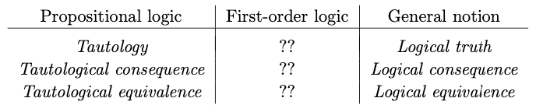

* options
  + FO logical truth (FO validity)
  + FO logical consequence (FO consequence)
  + FO logical equivalence (FO equivalence)

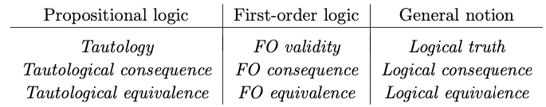

* note that so far we’ve only used the term “valid” to refer to arguments, not sentences
* in FOL we use *valid* to refer to both sentences that can’t be false, and arguments whose conclusions can’t be false if their premises are true
* **FO validity, FO consequence,** and **FO equivalence** are concepts that are meant to apply to those logical truths, consequences, and equivalences that are such solely in virtue of the **truth-functional connectives, quantifiers,** and **identity symbol**
  + we ignore specific meanings of names, function symbols, and predicates other than identity
* **why do we include identity?**
  + almost all FOLs use =
  + other predicates vary from one FOL to another
  + identity predicate is crucial for expressing many quantified noun phrases in English
    - *at least three tetrahedra*
    - *at most four cubes*
* **if we can recognize that a sentence is logically true without knowing the meanings of the names or predicates it contains, other than identity, then we’ll say the sentence is a FO validity**
* **if we can recognize that an argument is logically valid without appealing to the meanings of the names and predicates (other than identity), then the conclusion is a FO consequence of the premises, not just a logical consequence of them.**
* to show that a conclusion is not a first-order consequence of its premises, we use a method called **Replacement Method**
  + replace all predicates other than identity with new meaningless predicate symbols (also replace function symbols)
  + To check if S is a first-order validity, try to describe a circumstance, along with interpretations for the names, predicates, and functions in S, in which the sentence is false.
  + if there is no such circumstance, the original sentence is a first-order validity
  + To check if S is a first-order consequence of P1,...,Pn try to find a circumstance and interpretation in which S is false while P1,...,Pn are all true
  + if there is no such circumstance, the original inference counts as a first-order consequence
* when we compare this method with the truth-table methods for checking tautology and tautological consequence, we see that the latter methods are finite and known exactly in advance
* with first-order validity and consequence there are infinitely many possible circumstances that might be relevant
  + there is no correct and mechanical procedure like truth tables that always answers the question “is S a first order validity?”
  + there are procedures that do a pretty good job, e.g. FO Con
* what we’ve described thus far are rough methods and definitions
* later we will have more precise notions of first-order validity and consequence

What we can say, even with our rough definitions is:

* **if S is a tautology**, then it is always true no matter the truth values of the atomic sentences it is composed of.
  + I suppose that this means even when we change the sentences, which include wffs and quantifiers, ie quantified sentences. **Therefore S is a first-order validity too**
    - for example A | ~A is a tautology; we can sub in any sentence and it will remain a tautology, so it is also a first-order validity
  + the reverse is not necessarily true as we have seen: ∃x A | ∃x ~A
    - this is actually B | C, which is not a tautology, but we know that it is always true when we consider the quantifiers
* If S is a first-order validity, it is a sentence that is always true, taking into account not only truth-functional connectives, but also quantifiers, and identity predicate. It is also a logical truth (recall that not all logical truths are tautologies)
  + being always true in logically possible circumstances, it is a logical truth
  + the reverse is not necessarily true; for example,
* Is S is a tautological consequence of P1,...,Pn, then when the latter are all true, so is S. Then it is also a first-order consequence of these premises
* Similarly, if S is a first-order consequence of P1,...,Pn, then it is a logical consequence of these premises.
* First order validity represents the notion that a sentence is true in any logically possible situation because of its first-order structure.
* we don’t take into account particular names, function symbols, and predicate symbols aside from identity, that appear in a sentence or argument, but we do consider everything else (meaning connectives, quantifiers, identity predicate), in determining if a sentence is a first order validity, whether it is a first order consequence of a set of premises, or whether two sentences are first order equivalent to one another.

**Consider the figure below**

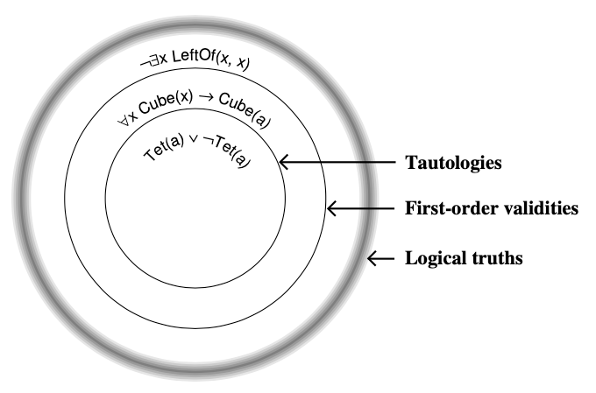

Tautologies are true due to the structure of the connectives.

First order validities are always true, but some of them are not always true based solely on the connectives; we need to take into account the quantifiers and the identity predicate.

* therefore, when checking if a sentence has first-order validity, we replace predicates with random names, so that we can be sure we aren’t taking into account their meaning
* to be a first-order validity, a sentence must be true no matter what the predicates are
* if we can come up with predicates that make the sentence false, we will have come up with a counterexample to the claim that the sentence is a first-order validity

Logical truths are always true, but some of them are not always true based solely on connectives, quantifiers, and identity predicate; for such logical truths, we see that they are always true by taking into account the meaning of the predicates.

**First-order equivalence and DeMorgan’s laws**

* two ways to apply to first-order sentences what we know about tautological equivalence
  + 1) if you apply the truth-functional form algorithm to a pair of sentences and the resulting forms are tautologically equivalent, then the original sentences are first-order equivalent
  + 2) turns out we can also apply principles of equivalence like DeMorgan inside the scope of quantifiers
    - *∀x (Cube(x) → Small(x))*
    - *∀x (~Small(x) → ~Cube(x))*
    - these sentences are first-order consequences of each other (recall that we don’t have any way to prove this; we can intuitively reach the conclusion that we can’t find any counterexample, since for each object we are essentially applying the law of contraposition to the first sentence, so the two are tautological consequences of each other)
    - these sentences are not tautologically equivalent however
    - Consider the wffs
      * *Cube(x)* *→ Small(x)*
      * *~Small(x) → ~Cube(x)*
    - more generally
      * *P(x) → Q(x)*
      * *~Q(x) → ~P(x)*
    - these formulas are not sentences; they have not truth value; we cannot speak of them being consequences of one another
    - but we can extend the notion of logical equivalence to wffs like these
    - **two wffs with free variables are logically equivalent if, in any possible circumstance, they are satisfied by the same objects; ie if when you replace their free variables with new names, the resulting sentences are logically equivalent**
* we now restate the principle of substitution of equivalents so it applies to full first-order logic

Let P and Q be wffs, possibly containing free variables, and let S(P) be any sentence containing P as a component part. Then if P and Q are logically equivalent: P ⟺ Q, then so too are S(P) and S(Q): S(P) ⟺ S(Q).

A proof requires the method of induction

Basically this says that if you have two logically equivalent wffs, they are interchangeable inside of sentences of which they are components. The different sentences obtained by the interchange of the equivalent wffs are themselves logically equivalent.

Now we can start with a quantified sentence (which contains wffs inside), and every time we replace a wff with a logically equivalent one, we obtain a new sentence that is logically equivalent to the previous one.

These sentences are not tautologically equivalent because…

**DeMorgan laws for quantifiers**

* there is a strong analogy between ∀and &, and between ∃ and |

In a world with four named blocks **a, b, c, d**

The sentence **∀x Cube(x)** is true if and only if **Cube(a) & Cube(b) & Cube(c) & Cube(d)** is true

The sentence **∃x Cube(x)** is true if and only if **Cube(a) | Cube(b) | Cube(c) | Cube(d)** is true

The sentence **~∀x Small(x)** is true if and only if ~(**Small(x) & Small(b) & Small(c) & Small(d))** which by DeMorgan is equivalent to (~**Small(x) | ~Small(b) | ~Small(c) | ~Small(d))**

which is true if and only if **∃x ~Small(x)**

The **DeMorgan laws for quantifiers** allow you to push a negation sign past the quantifier by switching the quantifier from **∀** to∃ or vice-versa

For example, if not everything has some property

**~∀x P(x)**

then it must be the case that some object does not have the property

**∃x ~P(x)**

The DeMorgan laws for quantifiers are aka **quantifier/negation equivalences**

**~∀x P(x)** ⟺ **∃x ~P(x)**

**~∃x P(x)** ⟺ **∀x ~P(x)**

**Connection with Aristotelian Sentences**

**All P’s are Q’s: ∀x P(x)** *→* ***Q(x)***

**~∀x P(x) *→ Q(x)* ⟺ ∃x ~(P(x) *→ Q(x)*) ⟺ ∃x ~(~P(x) | Q(x)) ⟺ ∃x P(x) & ~Q(x))**

The last equivalent sentence is “Some P’s are not Q’s”

Similarly, the negation of “Some P’s are Q’s” is “No P’s are Q’s.

**other quantifier equivalences**

∀x (P(x) & Q(x)) ⟺ ∀x P(x) & ∀x Q(x)

∀x (P(x) | Q(x)) not logically equivalent to ∀x P(x) | ∀x Q(x)

∃x (P(x) | Q(x)) ⟺ ∃x P(x) | ∃x Q(x)

∃x (P(x) & Q(x)) not logically equivalent to ∃x P(x) & ∃Q(x)

**null quantification**

* when we defined wffs, we did not insist that the variable being quantified actually occur free in the wff
* e.g. ∃x Cube(b)
* the question of whether the above sentence is true depends solely on whether Cube(b) is true or not
* thus it is first order equivalent to Cube(b)
* this sort of quantification is called **null quantification**
* in general
  + ∀x P ⟺ P
  + ∃x P ⟺ P
* Also
  + ∀x (P | Q(x)) ⟺ P | ∀x Q(x)
    - we have pushed the universal quantifier in past a disjunction
    - compare this with
      * ∀x (P(x) | Q(x)) not logically equivalent to ∀x P(x) | ∀x Q(x)
      * where we could not do that
  + Similarly, ∃x (P & Q(x)) ⟺ P & ∃x Q(x)
    - we have pushed the existential quantifier in past a conjunction
    - compare this with
      * ∃x (P(x) & Q(x)) not logically equivalent to ∃x P(x) & ∃Q(x)
      * where we could not do that

**first-order consequence and logical consequence**

Given

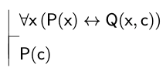

we can see that the conclusion is not first-order valid: taking into account the connectives and quantifiers, we can find a counterexample:

* If for every object x, P(x) is false then Q(x,c) is false, and for every object x Q(x,c) is false then P(x) is false, then the premise is true. In particular, P(c) is false then Q(c,c) is false, and Q(c,c) is false, then P(c) is false.
* And this particular scenario is logically possible.
* In this scenario, P(c) is false, yet the premise is true.
* Therefore the argument is not first-order valid.
* If we sub in specific predicates, we can make the argument logically valid, but still not first-order valid because even with new predicates, we don’t take their meaning into account in determining first order validity.
* The following argument

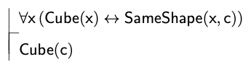

* is logically valid, but not first-order valid
* this represents the portion of the circle outside of first-order valid arguments, but inside logically valid arguments
* in order to make either argument valid, we need to add a new premise or premises expressing facts about the predicates involved

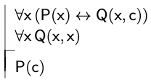

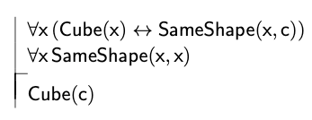

* now both arguments are logically valid no matter what the predicates mean

this technique of adding a premise whose truth is justified by the meanings of the predicates is one aspect of what is known as the **axiomatic method**

* it is often possible to bridge the gap between the intuitive notion of consequence and the more restricted notion of first-order consequence by systematically expressing facts about the predicates involved in our inferences
* the sentences used to express these facts are sometimes called **meaning postulates**, a special type of **axiom**

**In general, background assumptions about the range of relevant circum- stances are not made an explicit part of everyday reasoning, and this can give rise to disagreements about the reasoning’s validity. People with different as- sumptions may come up with very different assessments about the validity of some explicit piece of reasoning. In such cases, it is often helpful to articulate general facts about the presupposed circumstances. By making these explicit, we can often identify the source of the disagreement.**

**The axiomatic method can be thought of as a natural extension of this ev- eryday process. Using this method, it is often possible to transform arguments that are valid only relative to a particular range of circumstances into argu- ments that are first-order valid. The axioms that result express facts about the meanings of the relevant predicates, but also facts about the presupposed circumstances.**

**lemma:** there’s nothing special about a lemma; it’s a result that has been proved and that is being used in the course of proving another result

* lemmas have the same formal status as theorems or propositions, but are usually less important